# **Format for uploading details in GitHub and Slack in word file format**

**Student Name: Shrinivasa**

**Class and Sec: VI B**

**USN: 4AL17CS092**

|  |  |  |  |  |
| --- | --- | --- | --- | --- |
| **Online Test Details** | | | | |
| **Subject** | **Computer Graphics and Visualization, Cryptography Network Security and Cyber Laws** | | | |
| **Semester** | **VI - B** | | **Duration** | **30 Minutes, 40 Minutes** |
| **86%, 51%** | | **26/30, 31/60** | | |

**Encl: snapshot of the test result**

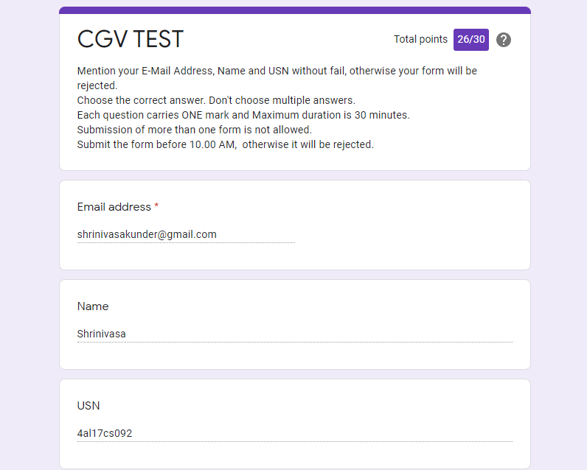

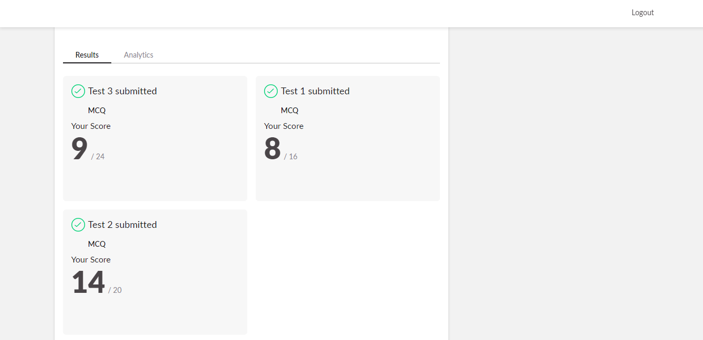

|  |  |  |  |
| --- | --- | --- | --- |
| **Certification Course Details** | | | |
| **Course** | **Introduction to Cloud** | | |
| **Certificate Provider** | **Cognitiveclass.ai** | **Duration** | **6 hours** |

**Encl: snapshots of the daily class activities (at least two snap shots)**

**Progress on 09-06-2020**

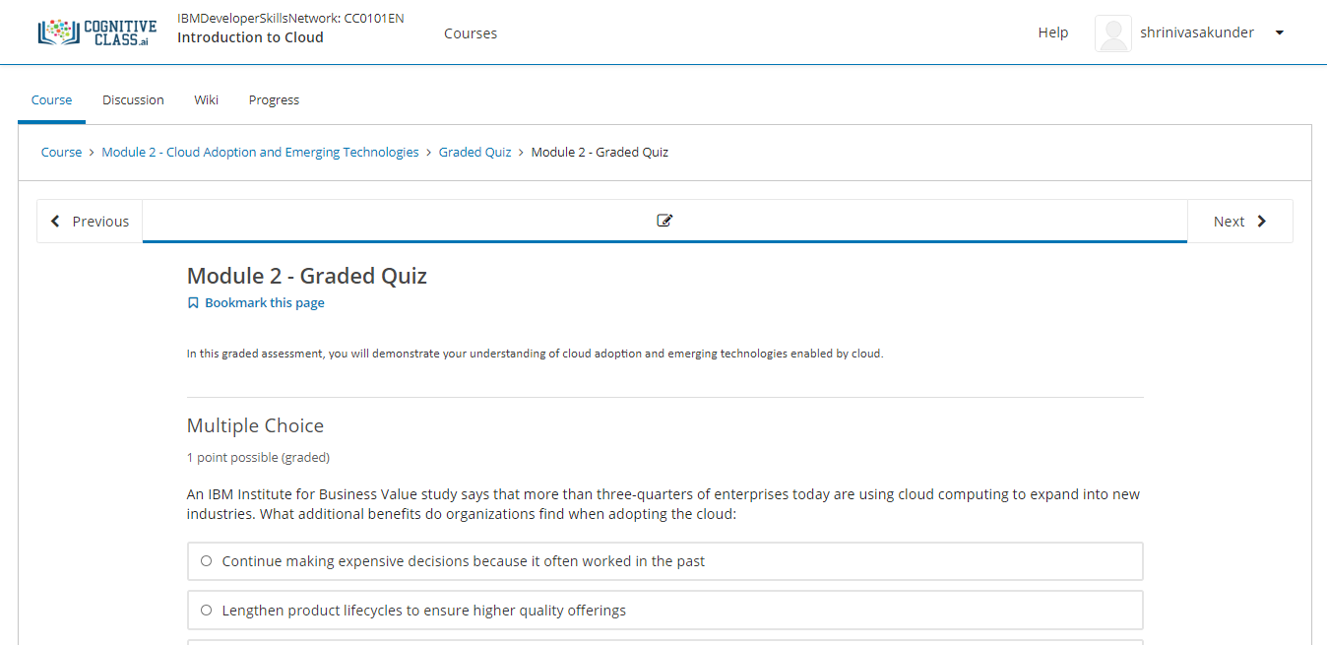

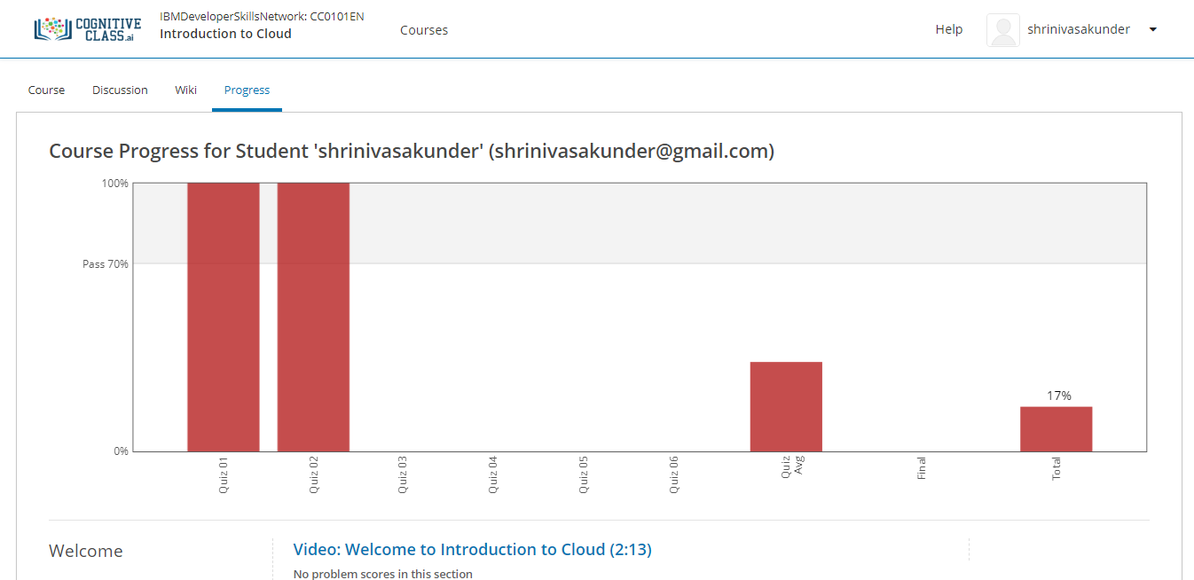

|  |  |
| --- | --- |
| **Coding Challenges** | |
| **Problem Statement: Pro1(python), Pro2(python), Pro3(c), Pro4(python), Pro5(java), Pro6(python), Pro7(java).** | |
| **Status: Completed** | |
| **Uploaded the report both in GitHub & Slack** | **Yes** |

**Encl: snapshots of your response to challenge.**

[**https://github.com/Shrinivasakunder/certification-and-online-coding/tree/master/Online%20coding**](https://github.com/Shrinivasakunder/certification-and-online-coding/tree/master/Online%20coding)

**1.** **Python Program to Check Whether a String is a Palindrome or not Using Recursion**

def pal(s):

if len(s) <= 1:

return True

else:

if s[0] == s[-1]:

return pal(s[1:-1])

else:

return False

a = input("Enter String:").lower()

if pal(a):

print("String Is A Palindrome")

else:

print("String Isn't A Palindrome")

**Output:**

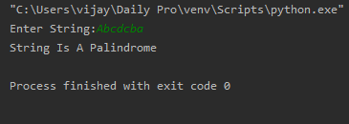

**2.** **Python Program to Reverse a String Using Recursion.**

def rev(s):

if len(s) == 0:

return s

else:

return rev(s[1:]) + s[0]

a = input("Enter String: ").lower()

print("The Reversed String: ", rev(a))

**Output:**

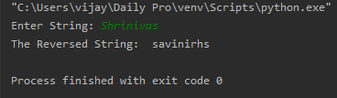

**3. Write a C Program to rotate the matrix by K times.**

#include <stdio.h>

#include <stdlib.h>

int main()

{

int a[100][100],m,n,k,i,j,x,y,z;

printf("Enter The Size Of The Matrix:\n");

scanf("%d%d",&m,&n);

printf("Enter The Elements Into Matrix:\n");

for(i=0;i<m;i++)

{

for(j=0;j<n;j++)

{

scanf("%d",&a[i][j]);

}

}

printf("Enter The K Value For Rotation:\n");

scanf("%d",&k);

int f,g;

printf("Matrix Before The Rotation:\n");

for(f=0;f<m;f++)

{

for(g=0;g<n;g++)

{

printf("%d\t",a[f][g]);

}

printf("\n");

}

for(x=0;x<m;x++)

{

for(z=0;z<k;z++)

{

int temp=a[x][0];

for(y=0;y<n-1;y++)

{

a[x][y]=a[x][y+1];

}

a[x][n-1]=temp;

}

}

printf("Matrix After The Rotation:\n");

int c,d;

for(c=0;c<m;c++)

{

for(d=0;d<n;d++)

{

printf("%d\t",a[c][d]);

}

printf("\n");

}

}

**Output:**

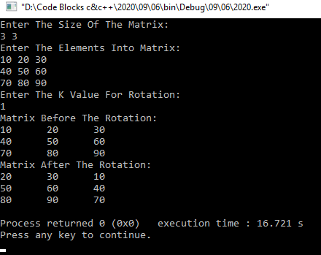

**4. Write a Python to implement Perfect Sum Problem.**

def printAllSubsetsRec(arr, n, v, sum):

if (sum == 0):

for value in v:

print(value, end=" ")

print()

return

if (n == 0):

return

printAllSubsetsRec(arr, n - 1, v, sum)

v1 = [] + v

v1.append(arr[n - 1])

printAllSubsetsRec(arr, n - 1, v1, sum - arr[n - 1])

def printAllSubsets(arr, n, sum):

v = []

printAllSubsetsRec(arr, n, v, sum)

n = int(input("Enter Number Of Elements: "))

a = []

print("Enter The Elements Into List:")

for i in range(n):

a.append(int(input()))

sum = int(input("Enter The K value: "))

print("Subsets with sum", sum, "are:")

print(printAllSubsets(a, n, sum))

**Output:**

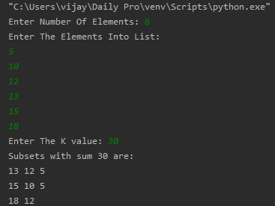

**5. write a java Program to print smallest and biggest possible palindrome word in a given string.**

package pblm;

import java.util.*;

public class pro2

{

public static void main(String[] args){

Scanner s = new Scanner(System.*in*);

System.*out*.println("Enter the string:");

String str = s.nextLine();

String w="", sp = "", bp="";

String[] ws = new String[100];

int t = 0, c = 0;

str = str.toLowerCase();

str = str + ' ';

for(int i = 0; i < str.length(); i++){

if(str.charAt(i) != ' '){

w = w + str.charAt(i);

}

else{

ws[t++] = w;

w = "";

}

}

for(int i = 0; i< t; i++){

String a=ws[i];

boolean flag = true;

for(int j = 0; j < a.length()/2; j++){

if(a.charAt(j) != a.charAt(a.length()-j-1)){

flag = false;

break;

}

}

if(flag==true){

c++;

if(c == 1)

sp = bp = ws[i];

else{

if(sp.length() > ws[i].length())

sp = ws[i];

if(bp.length() < ws[i].length())

bp = ws[i];

}

}

}

if(c == 0)

System.*out*.println("No palindrome is present in the given string");

else{

System.*out*.println("Smallest palindromic word: " + sp);

System.*out*.println("Biggest palindromic word: " + bp);

}

}

}

**Output:**

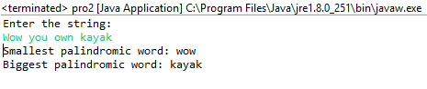

**6. Python Program to count even and odd numbers.**

n = int(input("Enter The Number Of Elements: "))

c = 0

print("Enter The Elements: ")

for i in range(n):

if int(input()) % 2 == 0:

c += 1

print("Number Of Even Numbers:", c, "\nNumber Of Odd Numbers:", n-c)

**Output:**

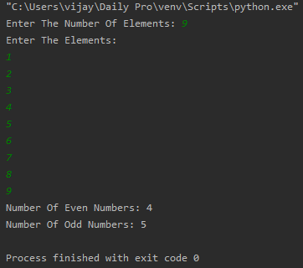

**7. Write a Java Program to remove all white spaces from a string without using replace().**

**package** pblm;

**import** java.util.*;

**public** **class** pro2{

**public** **static** **void** main(String[] args) {

Scanner s = **new** Scanner(System.***in***);

System.***out***.println("Enter The String:");

String str = s.nextLine();

**char**[] a = str.toCharArray();

String str1=" ";

**for**(**int** i=0;i<a.length;i++)

{

**if**(a[i]!=' ')

str1=str1+a[i];

}

System.***out***.println("Input String Without Spaces : "+str1);

}

}

**Output:**

